
The University of Azad Jammu and Kashmir
Department of Software Engineering
Digital Image Processing Lab
LAB REPORT
Lab Task # 01
Python Setup, Fundamentals, and Imports
Student Name: | Shadat Ali
Roll Number: | 2024-SE-36
Session: | 2024-28 (SE)
Semester: | Fifth
Lab Instructor: | Engr. Fahad Nisar
Date of Submission: | October 23, 2026

1. Objective
The objective of this lab is to set up a Python development environment on Windows and to practise the fundamental language constructs required for subsequent Digital Image Processing work. The lab covers the installation of Python and Visual Studio Code, the use of variables, conditional statements, loops, functions and collections, the installation of the NumPy, Pillow and Matplotlib packages, and the verification of the required import statements.

2. Environment Setup

2.1 Python Installation and Version Verification
Python 3 was downloaded from the official website (python.org) and installed with the “Add Python to PATH” option enabled. A new Command Prompt window was then opened, and the following commands were executed to verify the installation of Python and pip.
python --version
python -m pip --version

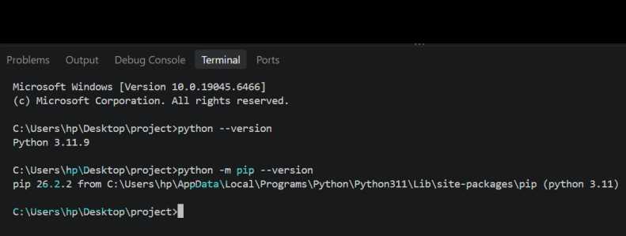
Figure 1: Python and pip version verificationThe output confirms that Python 3.11.9 and pip 26.2.2 are installed and operational.

2.2 Visual Studio Code and Python Extension
Visual Studio Code was installed, and the Python extension published by Microsoft was added through the Extensions panel (Ctrl + Shift + X). The installed Python 3 interpreter was then selected for the project using the “Python: Select Interpreter” command (Ctrl + Shift + P).
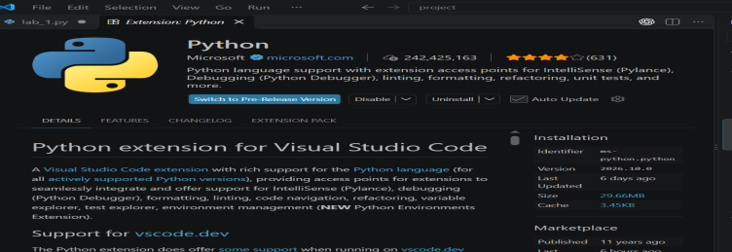
Figure 2: Python extension installed in Visual Studio Code

3. First Python Program
A file named hello.py was created in the project folder and executed from the terminal. The program consists of a comment and a single print statement.
# My first Python program
print('Hello, Digital Image Processing!')

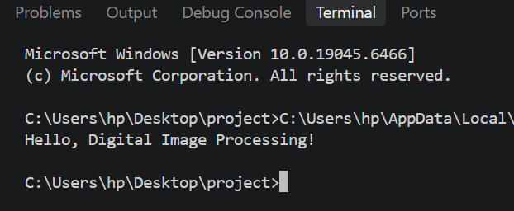
Figure 3: Execution of hello.py
- Basic Python Exercises
The following exercises were implemented in a single file, basics.py. Each section is identified by a comment, and four-space indentation is used throughout.

4.1 Exercise 1: Variables and Data Types
Variables of integer, string and Boolean types were created, and each value was printed together with its data type. The total number of pixels was computed as the product of width and height (640 × 480 = 307200).
width = 640
height = 480
image_name = "sample.png"
is_color = True

print(width, type(width))
print(height, type(height))
print(image_name, type(image_name))
print(is_color, type(is_color))

total_pixels = width * height
print("Total pixels:", total_pixels)

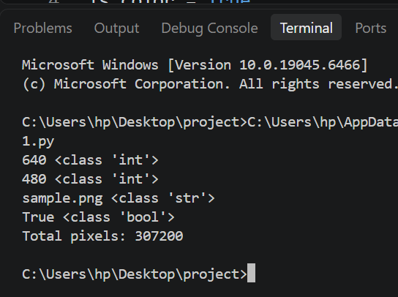
Figure 4: Output of Exercise 1

4.2 Exercise 2: Conditional Statements
An intensity value outside the range 0 to 255 is labelled Invalid. For valid values, an intensity of 128 or above is labelled Bright pixel, and any lower value is labelled Dark pixel. The boundary values -1, 0, 127, 128, 255 and 256 were tested.
for intensity in [-1, 0, 127, 128, 255, 256]:
if intensity < 0 or intensity > 255:
label = "Invalid"
elif intensity >= 128:
label = "Bright pixel"
else:
label = "Dark pixel"
print(intensity, "->", label)

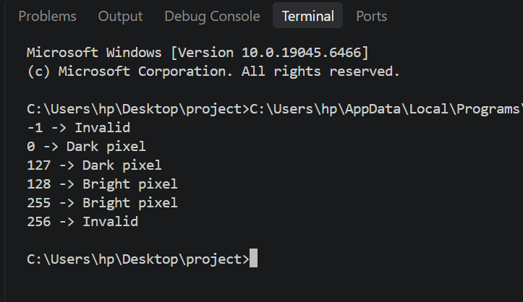
Figure 5: Output of Exercise 2

4.3 Exercise 3: for and while Loops
A for loop was used to classify the values 20, 130 and 255 using a threshold of 128. A while loop was then used to print the values 0, 1 and 2, with the counter updated in each iteration so that the loop terminates before 3.
for value in [20, 130, 255]:
if value >= 128:
print(value, "Bright pixel")
else:
print(value, "Dark pixel")

counter = 0
while counter < 3:
print(counter)
counter += 1

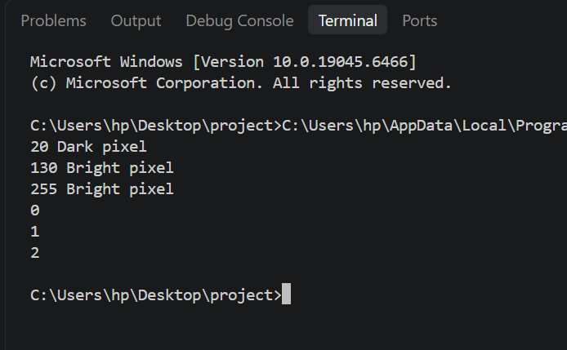
Figure 6: Output of Exercise 3

4.4 Exercise 4: Functions
The function is_bright() was defined with a default threshold of 128. It returns True when the pixel value is greater than or equal to the threshold and False otherwise. It was tested with the default threshold and with a custom threshold.
def is_bright(pixel, threshold=128):
return pixel >= threshold

print(is_bright(127))
print(is_bright(128))
print(is_bright(200, 210))

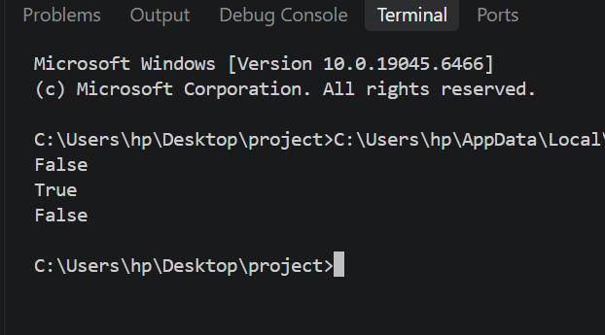
Figure 7: Output of Exercise 4

4.5 Exercise 5: Lists and Tuples
A list was created, modified by replacing its middle element, and extended using append(). A tuple was unpacked into two variables. A list is mutable, so its elements can be reassigned after creation, whereas a tuple is immutable, so its elements cannot be changed once it has been created.
pixels = [0, 128, 255]
print(pixels[0])
pixels[1] = 150
pixels.append(64)
print(pixels)
print(len(pixels))

size = (640, 480)
width, height = size
print(width, height)

# A list is mutable, so its items can be changed in place.
# A tuple is immutable, so its items cannot be changed.

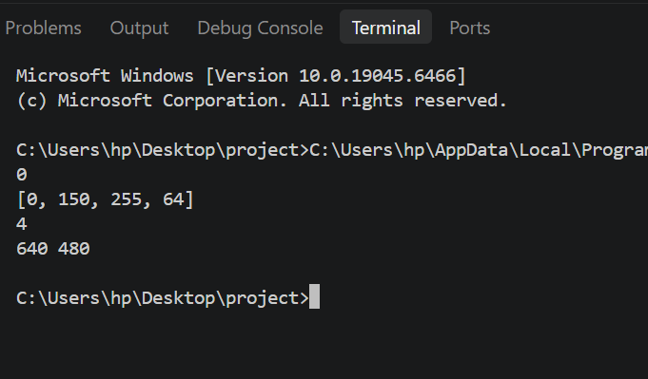
Figure 8: Output of Exercise 5

4.6 Exercise 6: Dictionaries and Sets
A dictionary was created and extended with a new key, and its values were accessed by key. A list containing duplicate labels was converted to a set, which retains only unique elements; the resulting set contains three labels.
image = {"width": 640, "height": 480}
image["mode"] = "RGB"
print(image["width"])
print(image["mode"])

labels = set(["cat", "dog", "cat", "bird"])
print(len(labels))

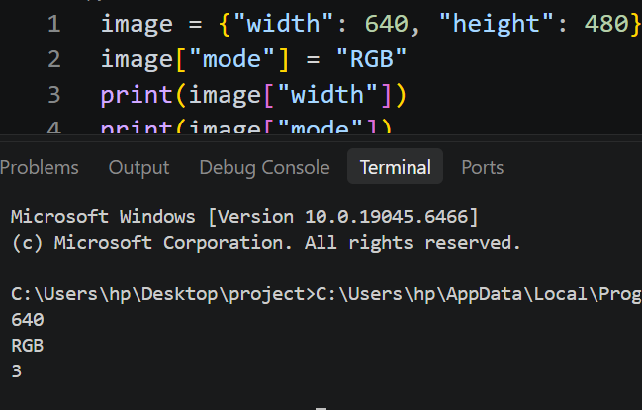
Figure 9: Output of Exercise 6

5. Installation of Required Packages
The NumPy, Pillow and Matplotlib packages were installed using pip. NumPy provides support for numerical arrays, Pillow provides image handling tools, and Matplotlib is used for plotting.
python -m pip install numpy pillow matplotlib

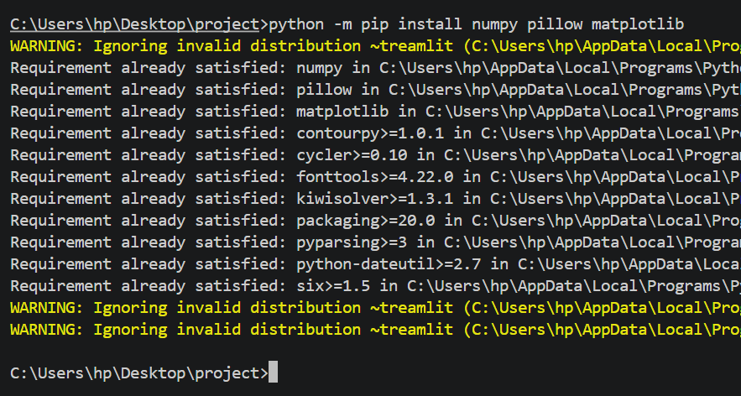
Figure 10: Installation of NumPy, Pillow and Matplotlib using pip

6. Verification of Import Statements
A Python file containing only the following import statements was created and executed from the project folder. The program completed without errors and returned to the command prompt with no output, which confirms that all three libraries are installed correctly.
import numpy as np
from PIL import Image
import matplotlib.pyplot as plt

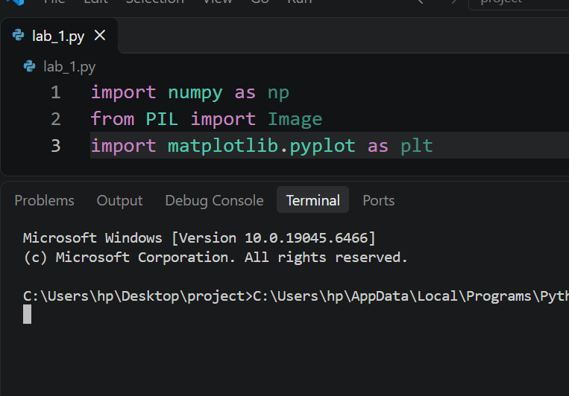
Figure 11: Import statements and successful execution

7. Conclusion
Python is the programming language and interpreter used to execute programs, whereas pip is the package manager used to download and install additional libraries for it. Running pip as “python -m pip” ensures that packages are installed into the same Python installation that runs the code. Import statements make installed libraries available within a program: NumPy (np) is used for array computation, Pillow’s Image module is used for opening and saving images, and matplotlib.pyplot (plt) is used for displaying plots and images.
In this lab, a working Python environment was established and the basic programming constructs required for later Digital Image Processing tasks were practised successfully.

